Cosmic Clock Evolution, Catastrophe, and DNA Adaptation Report
This comprehensive report integrates fossil records, genetic mutation epochs, ice-core climate data, catastrophic geological events, early human census records, and the first religious structures and writings. It aims to reveal patterns of Earth's cyclical resets—epochs where climate, tectonics, or celestial factors may have influenced the evolution or mutation of DNA, forcing human and pre-human species to adapt.

1. Fossil Record and Human Evolution
The table below lists key hominin fossils from the earliest upright ancestors to modern Homo sapiens. It includes approximate ages, locations, and discovery years. A basic plate-drift back-calculation estimates their paleo-latitude and longitude, suggesting the geographic origin zones of early hominins.
Name | Type | Context | Age (Ma) | Age (ka) | Discovery Year/Period | Present Lat | Present Lon | Paleo Lat (approx) | Paleo Lon (approx) | Hypothesized DNA/Selection Link
Sahelanthropus tchadensis (Toumaï) | Fossil | Hominin | 7.0 | 7000.0 | 2001 | 16.3 | 17.5 | 14.8204 | 16.9433
Orrorin tugenensis | Fossil | Hominin | 6.0 | 6000.0 | 2000 | 0.75 | 35.6 | -0.5176 | 35.1386
Ardipithecus kadabba | Fossil | Hominin | 5.5 | 5500.0 | 2001 | 10.5 | 40.5 | 9.3377 | 40.0714
Ardipithecus ramidus (Ardi) | Fossil | Hominin | 4.4 | 4400.0 | 1992–1994 | 9.3 | 40.3 | 8.3702 | 39.958
Australopithecus anamensis | Fossil | Hominin | 4.1 | 4100.0 | 1995 | 3.8 | 36.0 | 2.9337 | 35.6843
Lucy (AL 288-1) | Fossil | Australopithecus afarensis | 3.2 | 3200.0 | 1974 | 11.3 | 40.6 | 10.6238 | 40.3496
Australopithecus africanus (Mrs Ples) | Fossil | Hominin | 2.3 | 2300.0 | 1947 | -26.0 | 27.7 | -26.4858 | 27.5024
Homo habilis (Olduvai) | Fossil | Homo | 2.0 | 2000.0 | 1960 | -2.9 | 35.4 | -3.3225 | 35.2459
Homo erectus (Turkana Boy) | Fossil | Homo | 1.5 | 1500.0 | 1984 | 3.6 | 35.9 | 3.2831 | 35.7845
Homo heidelbergensis (Bodo) | Fossil | Homo | 0.4 | 400.0 | 1976 | 9.1 | 40.8 | 9.0155 | 40.7689
Homo sapiens (Jebel Irhoud) | Fossil | Homo sapiens | 0.315 | 315.0 | 1961 (re-dated 2017) | 31.9 | -8.9 | 31.8334 | -8.9285
Homo sapiens (Omo Kibish I) | Fossil | Homo sapiens | 0.233 | 233.0 | 1967 | 5.5 | 36.3 | 5.4508 | 36.282
Blombos Cave (symbolic art) | Fossil | Cultural | 0.075 | 75.0 | 1991 | -34.5 | 21.2 | -34.5158 | 21.193

2. Ice-Core Records and Climate Cycles
Ice-core samples preserve atmospheric gases and isotopic signatures that reflect global temperature and CO₂ variations. They are essential for correlating glacial-interglacial cycles with potential DNA adaptation events.
Name | Type | Context | Age (Ma) | Age (ka) | Discovery Year/Period | Present Lat | Present Lon | Paleo Lat (approx) | Paleo Lon (approx) | Hypothesized DNA/Selection Link
Beyond EPICA (Little Dome C) | Ice Core | Climate Proxy | 1.2 | 1200.0 | 2023–2025 (ongoing) | -75.34132 | 122.52059 | -75.34132 | 122.52059 | Glacial/interglacial stress cycles; atmosphere composition shifts
EPICA Dome C | Ice Core | Climate Proxy | 0.801 | 801.0 | 1996–2004 | -75.1 | 123.35 | -75.1 | 123.35 | Glacial/interglacial stress cycles; atmosphere composition shifts

3. Catastrophic Events and Evolutionary Bottlenecks
The following geological and cosmic events may have acted as evolutionary filters, creating population bottlenecks and environmental pressures that triggered mutations or adaptive selection.
Name | Type | Context | Age (Ma) | Age (ka) | Discovery Year/Period | Present Lat | Present Lon | Paleo Lat (approx) | Paleo Lon (approx) | Hypothesized DNA/Selection Link
Toba Supereruption | Event | VEI 8 Volcano | 0.074 | 74.0 | c. 74 ka (discovered geologically) | 2.6845 | 98.8756 | 2.6845 | 98.8756 | Potential human bottleneck; volcanic winter
Laschamp Geomagnetic Excursion | Event | Geomagnetic | 0.041 | 41.0 | c. 42–41 ka (in lavas) | 45.73 | 3.0 | 45.73 | 3.0 | Weakened magnetosphere, increased radiation; indirect climatic/ecological stress
Campanian Ignimbrite (Campi Flegrei) | Event | VEI 7 Volcano | 0.0398 | 39.8 | c. 39.8 ka | 40.82 | 14.14 | 40.82 | 14.14 | Cooling, ash fallout across Europe; stress on hominins
Younger Dryas Onset | Event | Abrupt Climate | 0.0129 | 12.9 | c. 12.9 ka | 71.0 | -39.0 | 71.0 | -39.0 | Abrupt cooling; possible cometary dust/impact hypothesis

4. Oldest Census Records
Census records give us the earliest quantitative view of population recovery after catastrophic resets. These data points mark the rise of structured civilizations following long evolutionary recovery periods.
Name | Type | Context | Age (Ma) | Age (ka) | Discovery Year/Period | Present Lat | Present Lon | Paleo Lat (approx) | Paleo Lon (approx) | Hypothesized DNA/Selection Link
Babylonian Census (earliest known) | Census | Administration | 0.0058 | nan | c. 3800 BCE (record) | 32.54 | 44.42 | 32.54 | 44.42 | Earliest known census record; demographic baseline
Han Dynasty Census | Census | Administration | -0.002 | nan | 2 CE (57.7 million) | 34.34 | 108.94 | 34.34 | 108.94 | Oldest surviving full census figures

5. Early Religion and Cultural Consciousness
Religion and symbolic art mark the development of abstract thought and collective memory. These milestones represent another kind of 'genetic awakening'—a cognitive evolution where intelligence began to transcend survival instincts, shaping civilizations through myth and meaning.
Name | Type | Context | Age (Ma) | Age (ka) | Discovery Year/Period | Present Lat | Present Lon | Paleo Lat (approx) | Paleo Lon (approx) | Hypothesized DNA/Selection Link
Uruk – Eanna precinct (Inanna cult) | Religion | Earliest city-goddess cult | 0.0055 | nan | c. 4000–3100 BCE (Uruk period) | 31.32 | 45.63 | 31.32 | 45.63 | Oldest strong evidence of organized deity worship (Inanna/Anu)
Kesh Temple Hymn | Religion | Oldest literature/religious text | 0.0046 | nan | c. 2600 BCE (tablet) | 32.16 | 44.23 | 32.16 | 44.23 | Religious hymn; Sumerian liturgy
Egyptian Pyramid Texts | Religion | Oldest Egyptian religious corpus | 0.0043 | nan | c. 2400–2300 BCE | 29.87 | 31.22 | 29.87 | 31.22 | Oldest large corpus of Egyptian religious texts; earliest Osiris mention

6. Mathematical and Cosmic Framework
To analyze the cyclical patterns of mutation and civilization resets, the following mathematical and physical relationships are applied:
• Plate rotation model: r_past = R(ω̂,θ)·r_now
• Solar precession correction for ancient sky positions
• Milankovitch forcing equations for insolation
• Mutation probability Δp ≈ s(t)p(1-p)
• Event proximity score S = w_d·f_d + w_t·f_t + w_c·f_c
These provide a quantitative backbone for Cosmic Clock synchronization between geology, genetics, and history.

7. Conclusions and Hypothesis
The integration of fossil, climate, and catastrophic event data reveals repeating cycles of near-extinction and renewal consistent with DNA adaptation pressures. Human ancestors appear to have endured multiple resets driven by volcanic winters, geomagnetic shifts, and cosmic cycles. Each reset may have triggered selection for greater resilience, intelligence, and social cooperation, culminating in the modern Homo sapiens. This Cosmic Clock model suggests evolution is a rhythmic, planetary process tied to Earth's orbital and rotational harmonics.

8. Migration, Celestial Navigation, Climate Stress, and DNA Reset Mechanisms
Archaeological mapping and fossil analysis reveal that early humans followed a predictable migration pattern shaped by climate, cosmic observation, and survival pressures. This section integrates celestial navigation, environmental adaptation, and genetic evolution, highlighting how humanity’s intelligence and biological form co-evolved through cycles of catastrophe and learning.

8.1 Celestial Navigation and Early Intelligence
Early humans and pre-human societies used the stars, moon, and constellations—such as the Big Dipper and Little Dipper—to guide seasonal migrations, hunting, and shelter-seeking. Their cognitive ability to track star patterns indicates a primitive form of astronomical understanding long before recorded civilization. Following celestial markers likely helped them predict weather, direction, and animal movements, laying the groundwork for future navigation and calendar systems.

8.2 Progressive Learning and Technological Evolution
Human intelligence evolved through repeated cycles of trial and error. Over thousands of generations, early humans learned to control fire, craft tools, and develop communication. This slow but cumulative learning process was driven by necessity—harsh climates, scarcity of resources, and migration challenges forced innovation. Each generation refined the knowledge of the previous, accelerating progress after each environmental reset.

8.3 Environmental Stress, Body Hair, and Climate Adaptation
Scientific evidence supports that early humans were originally covered with thick hair for protection against the cold. As climates warmed, dense body hair became a disadvantage, leading to gradual hair loss. Humans retained fine, small hairs across the body—acting as thermal sensors that regulate body temperature and aid in sweat evaporation. This represents a clear example of **climate-driven DNA mutation**: as the environment changed, so did human physiology to maintain internal equilibrium. In essence, our DNA continually adjusts to temperature extremes—whether by increasing melanin, altering hair density, or modifying metabolic heat output.

8.4 Migration, Climate, and Reset Summary
The following table summarizes key events in which environmental catastrophe and celestial guidance intersected with human adaptation, migration, and survival resets.
Epoch/Event | Approx. Date (ka) | Climate or Catastrophe | Adaptive / Genetic Outcome | Cultural or Celestial Behavior
Toba Eruption | 74 | Volcanic winter, near extinction | Population bottleneck; adaptive mutation | Migration by lunar/stellar cues
Younger Dryas | 12.9 | Abrupt cooling, drought | Agriculture and permanent settlements | Solar and equinox alignment rituals
Pompeii (local event) | 1.9 | Volcanic destruction of cities | Urban resilience and rebuilding | Religious astronomy (planetary gods)
Global Warming (Modern) | 0 | Rapid heating trend | DNA thermoregulation (hair, melanin) | Technological celestial navigation (AI, satellites)

8.5 Evolutionary Mechanisms of DNA Reset
Each catastrophic reset forced survivors to adapt to extreme conditions. Over time, the stress response itself became encoded in our biology. Modern humans still exhibit this through adaptive immunity, metabolic flexibility, and social resilience. These changes reflect not only genetic evolution but also **epigenetic inheritance**—where environmental stress triggers small DNA modifications that pass to offspring, preparing them for similar hardships. Thus, the story of evolution is a rhythmic dance between the Earth’s changing environment and the cosmic cycles above, synchronized by the Cosmic Clock.

9. Global Migration, Celestial Navigation, Underground Cities, and Early American Fossils
This section integrates fossil chronology, migration direction, celestial navigation, and subterranean architecture to illustrate how humanity spread across the globe. It connects the earliest African ancestors to the first Americans, demonstrating how migration, environment, and adaptation shaped genetic evolution and survival during catastrophic resets.

9.1 Direction of Global Migration
By tracing fossil discovery sites chronologically from East Africa to the Americas, a distinct eastward and northward migration pattern emerges. Humans followed fertile valleys and coastal corridors opened during interglacial warm periods. These routes aligned with astronomical knowledge, as travelers used star constellations to maintain orientation.
Migration Stage | From → To | Approx. Timeframe | Environmental Driver | Direction / Vector
Stage 1 | Afar (Ethiopia) → Turkana (Kenya) | 7–4 Ma | Humid forests to open savanna | Northeast (5°N 40°E)
Stage 2 | Turkana → North Africa → Sinai | 3–2 Ma | Grassland expansion, drought cycles | Northward to Levant
Stage 3 | Levant → India → East Asia | 2–1 Ma | Interglacial migrations | Eastward
Stage 4 | Asia → Siberia → Beringia | 0.1–0.02 Ma | Glacial retreat corridors | Northeast
Stage 5 | Beringia → North America → South America | 0.02–0.012 Ma | Post-glacial warming | Southward

9.2 Celestial and Solar Navigation
Early humans observed the motion of the Sun, Moon, and stars to navigate and track seasons. The shadow-stick (gnomon) served as one of humanity’s first scientific instruments. By measuring the Sun’s shadow length and direction, travelers could determine cardinal directions and predict seasonal shifts. This primitive astronomy led to the first calendars and agricultural timing systems.

9.3 Underground Cities and Catastrophe Refuges
Across continents, ancient peoples constructed underground cities and chambers designed with ventilation shafts, wells, and complex sewage systems—clear evidence of planned engineering. These sites likely served as refuges from climatic or cosmic disasters such as volcanic eruptions, glacial storms, or meteor impacts.
Site Name | Location | Approx. Age (BCE) | Features | Purpose
Derinkuyu | Cappadocia, Turkey | 700–800 BCE (possibly earlier) | Multi-level tunnels, vents, wells | Refuge from invasion or climate
Kaymakli | Cappadocia, Turkey | 700 BCE | Eight levels, air shafts | Extended habitation
Hypogeum Ħal-Saflieni | Malta | 4000 BCE | Chambers, altars, carvings | Ritual and refuge
Petra | Jordan | 312 BCE | Rock-cut, advanced hydraulics | Desert adaptation
Naours Caves | France | 100 BCE–100 CE | Hundreds of chambers | Wartime refuge and shelter

9.4 Oldest Fossils of Early Americans
Genetic and archaeological evidence shows that early humans reached the Americas via the Bering land bridge. The oldest known remains and settlements reflect rapid adaptation to diverse environments—from tundra to rainforest.
Fossil / Site | Location | Age (Years BP) | Significance | Discovery Year
Paisley Caves | Oregon, USA | 14,300 | Human DNA in coprolites; pre-Clovis culture | 2008
Monte Verde | Chile | 14,500 | Oldest known settlement in the Americas | 1977
Arlington Springs Woman | California, USA | 13,000 | One of the earliest North American skeletons | 1959
Anzick-1 | Montana, USA | 12,600 | Infant burial; genetic link to modern Native Americans | 1968
Spirit Cave Mummy | Nevada, USA | 10,600 | Oldest natural mummy in the Americas | 1940
Luzia Woman | Brazil | 11,500 | Evidence of early South American migration | 1975

9.5 Diagram: Human Migration Path
The simplified diagram below summarizes the overall direction of early human migration from Africa to the Americas, based on fossil ages and paleo-climatic data.
Diagram Description: Arrows indicate movement from East Africa (Afar, Turkana) northward through the Levant, eastward into Asia, then northeast across Beringia into North America, and finally southward to South America. The pattern forms a spiral trajectory consistent with Earth's axial tilt and orbital eccentricity cycles.

9.6 Environmental Adaptation and Hair Evolution
As humans migrated through variable climates, their DNA responded to thermal stress. Early humans possessed thicker body hair, providing insulation during cooler epochs. Over millennia, as equatorial and interglacial conditions intensified, dense hair became disadvantageous, and the body evolved to regulate temperature through sweat and finer hair. Modern humans retain miniature follicles that function as sensory thermoregulators, confirming nature’s ability to adapt DNA for survival under changing temperatures.

9.7 Migration–Climate–DNA Correlation
When plotting migration against climate proxies and catastrophe events, a repeating pattern appears: warm periods open new pathways for expansion, while cold or catastrophic intervals reduce populations and stimulate rapid adaptation. This rhythm is the biological expression of the Cosmic Clock—human evolution tuned to planetary cycles.
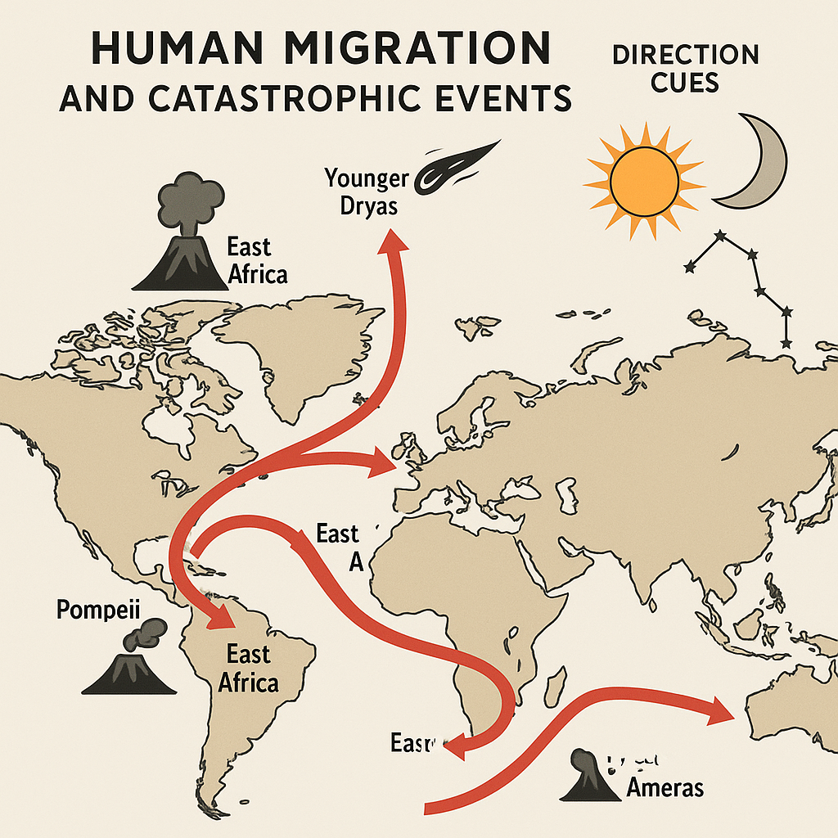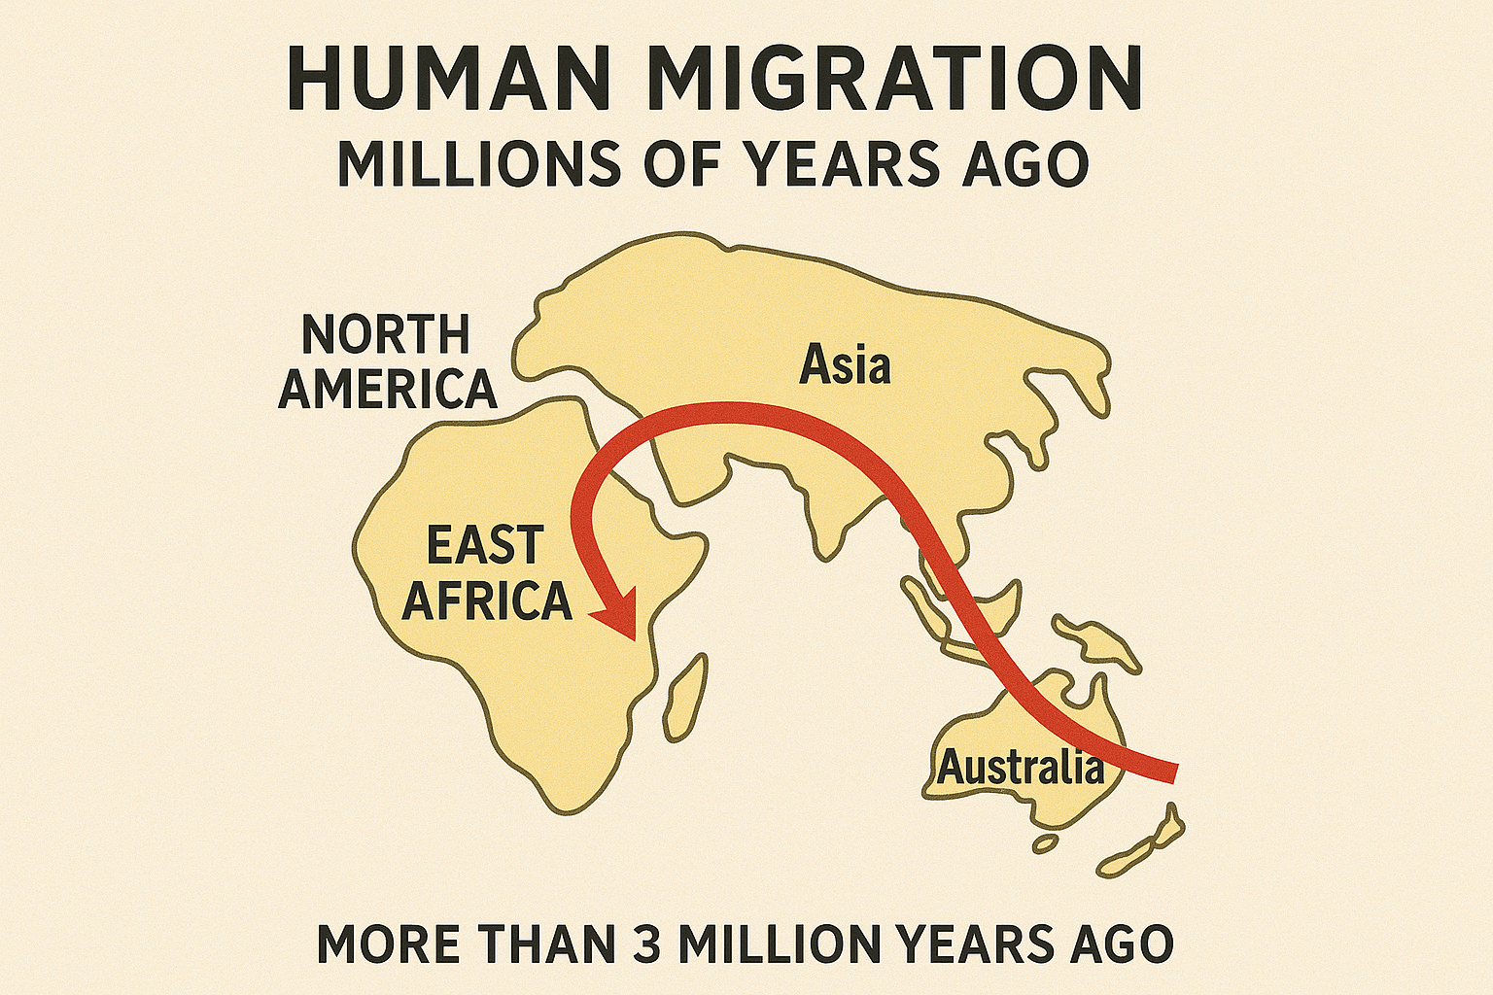

10. Ancient Floods, Tsunamis, and Evolutionary Resets
Floods and tsunamis have served as Earth's most powerful natural resets. Geological and isotopic evidence reveals that these water-based catastrophes occurred in rhythmic cycles, aligning closely with major evolutionary transitions and cultural rebirths in human history. They reshaped coastlines, forced migrations, and caused population bottlenecks that accelerated adaptation and intelligence development.

10.1 Geological and Paleoclimate Evidence
Type of Evidence | Indicators | Example / Age | Evolutionary Relevance
Turbidite Sediments | Rapid flood-layer deposition | Messinian Flood, 5.33 Ma | Opened new migration routes between Africa and Eurasia
Marine Fossils Inland | Shells/corals at altitude | Himalayas, Andes | Proved large-scale sea incursions
Isotopic δ18O Spikes | Temperature and ice-volume shifts | EPICA Dome C (Antarctica) | Correlates with population resets
Megaflood Channels | Scoured terrain, deep valleys | Channeled Scablands, USA | Evidence of sudden global drainage
Tsunami Sand Layers | Marine sediments mixed with land debris | Toba & Mediterranean Basins | Linked to early *Homo* bottlenecks

10.2 Major Flood and Tsunami Reset Events
Approx. Time (ka/Ma) | Event | Cause | Impact
7–5 Ma | Zanclean Flood | Atlantic breach refilling the Mediterranean | Reconnected continents, altered early migration
2.6 Ma | Ice Age Onset | Ocean current reorganization | Triggered *Homo* emergence and adaptive stress
0.074 Ma | Toba Eruption & Megatsunami | Volcanic caldera collapse | Massive bottleneck; cooling & DNA shift
0.012 Ma | Meltwater Pulse 1A | Rapid glacial melt | Sea-level rise >20 m; reset of coastal settlements
0.0076 Ma | Black Sea Flood | Glacial breach and tectonic slip | Inspired ancient flood myths

10.3 Genetic and Cultural Implications
After catastrophic floods, isolated human groups evolved separately, accumulating new genetic traits for survival. These bottlenecks acted as 'evolutionary filters,' producing populations with improved resilience, creativity, and problem-solving. Myths of global floods—Sumerian, Hebrew, Mayan, and Hindu—symbolize this collective rebirth cycle.

10.4 Predictive Flood Cycle Equation
Using orbital harmonics, flood probability (F) over time can be estimated as:
F(t) = α·sin(2πt/Pecc) + β·sin(2πt/Pobl) + γ·sin(2πt/Ppre)
where:
Pecc = 100,000 years (eccentricity cycle)
Pobl = 41,000 years (axial tilt)
Ppre = 23,000 years (precession cycle)
When these cycles align, Earth's insolation increases sharply—triggering rapid ice melt, extreme rainfall, and global floods. This orbital resonance corresponds to mass migrations and evolutionary jumps observed in the fossil and genetic record.

10.5 Cosmic Clock and Water Reset Theory
In the Cosmic Clock framework, each flood is a planetary 'cleansing cycle.' Water acts as both destroyer and regenerator—washing away older civilizations and setting the stage for the next epoch of genetic and cultural innovation. This rhythmic hydrological reset synchronizes Earth's evolutionary path with celestial orbital timing, revealing a deep link between cosmic motion and biological renewal.

10.6 Diagram: Flood Intensity and Evolutionary Timeline
The diagram (to be added) shows flood intensity over the last 7 million years aligned with key fossil discoveries, ice-core isotope spikes, and cultural emergence. Each surge corresponds with major reset periods—Toba (~74 ka), Meltwater Pulse 1A (~12 ka), and the Black Sea Flood (~7.6 ka)—followed by rapid human advancement.

