Einstein Master Equation — Progress Toward a Unified Solution
This document summarizes the Einstein Master Equation, its physical meaning, and how close modern science — and unified frameworks like the Quantum Slit Expansion Model — are to solving it. The discussion integrates General Relativity, Quantum Field Theory, vacuum fluctuations, and self-consistent spacetime feedback as envisioned by Einstein’s ultimate unification goal.

1. Einstein’s Field Equation
Einstein’s General Relativity (GR) is governed by the field equation:
G_{μν} + Λ g_{μν} = 8πG T_{μν}
This equation links the curvature of spacetime (left side) with the energy and matter content of the universe (right side).
In simpler terms: mass and energy tell space how to curve, and curved space tells matter how to move.

2. The Quantum Challenge
Quantum Field Theory (QFT) describes particles and forces as fluctuations of quantum fields. However, when we try to combine QFT with GR, we find inconsistencies — gravity resists quantization due to the non-linear structure of spacetime curvature.
Physicists have extended Einstein’s equations to include quantum expectations, leading to the semi-classical form:
G_{μν} = 8πG ⟨ T̂_{μν} ⟩
Here, ⟨T̂_{μν}⟩ represents the quantum average of the stress–energy operator. This is the foundation of the Einstein Master Equation — a coupled system linking geometry (G_{μν}) with quantum states (ρ̂ or |Ψ⟩).

3. The Einstein Master Equation
The Master Equation unifies quantum dynamics and geometry:
G_{μν}[g] = 8πG (⟨T̂_{μν}⟩ + T_{μν}^{(vac)} + F_{μν}^{(feedback)})
and
dρ̂/dt = -i/ħ [Ĥ(g), ρ̂] + L_{vac}[ρ̂] + L_{feedback}[ρ̂]
The first equation governs spacetime curvature; the second governs the evolution of quantum states. Together, they must converge to a self-consistent solution — geometry and energy determining each other.

4. Quantum Slit Expansion Model of the Universe
Recent interpretations propose that the early universe behaved like a quantum interference pattern — a “multi-slit” system where quantum fluctuations from the Big Bang expanded and interfered, forming the structure of galaxies, voids, and cosmic filaments.
In this model, each galaxy corresponds to a standing wave node in the quantum field, while stars act as stabilizers within local curvature wells. The vacuum acts as a dynamic field that shapes, stretches, and stabilizes spacetime loops — producing the large-scale cosmic web we observe today.
Below is the conceptual diagram illustrating the Quantum Slit Expansion Model:
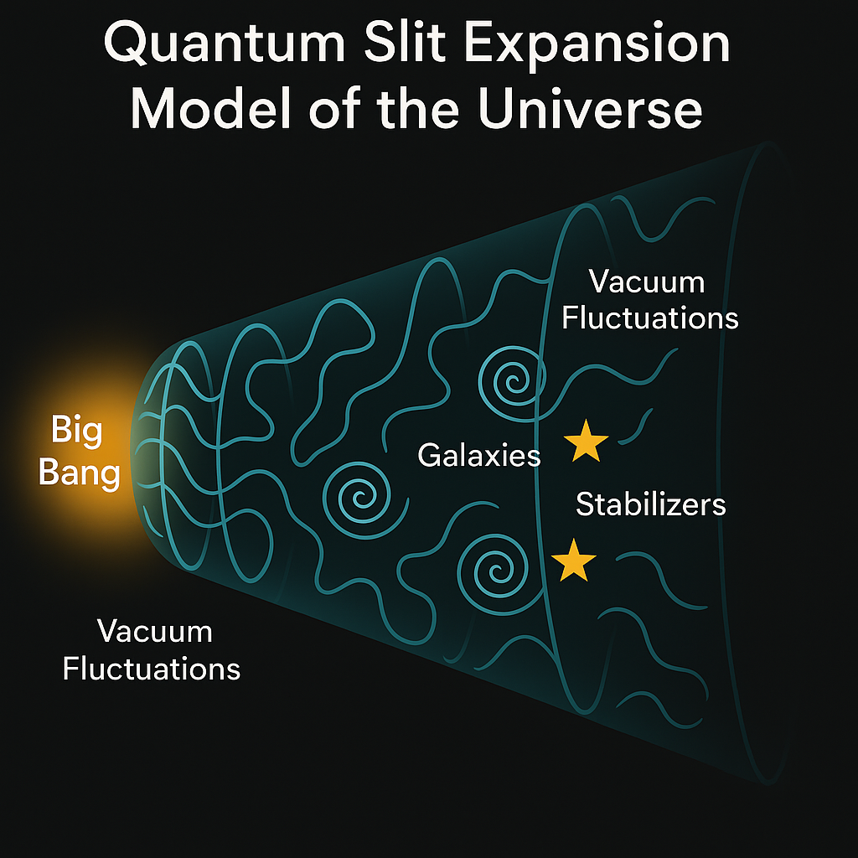

5. How Close Are We to Solving It?
Modern physics has achieved partial success toward Einstein’s dream:
• The Einstein field equations are solved for cosmology (Friedmann equations) and black holes (Schwarzschild, Kerr metrics).
• Quantum mechanics is unified with electromagnetism and nuclear forces under the Standard Model.
• Semi-classical gravity can describe phenomena like Hawking radiation and inflation.
However, a full, *self-consistent spacetime–quantum field solution* — where geometry and quantum state evolve together — remains unsolved. The missing pieces include:
1. A finite, renormalized quantum stress–energy tensor (vacuum energy problem).
2. A method for coupling quantum evolution (density matrix) with spacetime curvature.
3. A stable feedback law (like CST modulation) to maintain equilibrium.
If achieved, this would represent the true “Einstein Master Equation” — a unified equation governing both the curvature of spacetime and the evolution of all quantum fields within it.

6. Summary
Einstein’s Master Equation aims to describe reality in its totality — matter, energy, and geometry as one dynamic field.
Today, we can model parts of this system with remarkable accuracy, but the full unification — the bridge between quantum mechanics and gravity — remains the final frontier of physics.

