Transwarp Beaming and CST Navigation Stability

1. Adding Space Volume into the Navigation Model
In Alcubierre-style warp metrics, the metric tensor is modified:
ds² = -c² dt² + (dx - vₛ(t) f(rₛ) dt)² + dy² + dz²
Here f(rₛ) is a shape function describing the bubble. We explicitly parameterize the space volume inside the bubble:
V_bubble(t) = ∫ sqrt(det(gᵢⱼ)) d³x
This is the amount of space being 'carried'. It can be added to CST navigation equations as a space mass term:
S(t) = ρ_space × V_bubble(t)

2. Incorporating Tunnel Curvature into CST Time Sync
CST time synchronizes clocks across the tunnel. If the tunnel's cross-section or curvature changes, the light-path length inside the bubble changes:
Δt_CST = L_path(t) / c_eff(t)
where L_path(t) = ∫ sqrt(gᵢⱼ dxⁱ dxʲ).

3. Space Usage Fraction
For a circle warp tunnel:
A_circle = πR² (total cross-sectional area)
A_bubble(t) = cross-section of actual curved space
η(t) = A_bubble(t) / A_circle
If η fluctuates, instabilities occur. Stable tunnels require η ≈ constant.

4. Relativistic / Transwarp Regime
In relativistic physics, speed is limited locally by c, but space shaping allows effective speeds beyond c. The warp factor depends on the bubble shape derivative:
v_eff(t) = v_ship(t) + ẋ_bubble(t).

5. Suggested Combined Equation for CST Nav
Define a combined state vector:
Ω(t) = [x(t), v_ship(t), V_bubble(t), η(t), Δt_CST(t)]ᵀ
with dynamics:
dΩ/dt = F(Ω, warp controls).

6. Stability Criterion
Require:
|dη/dt| < ε, |dV_bubble/dt| < ε_V
This ensures CST clocks and tunnel curves remain aligned and stable.

Diagram
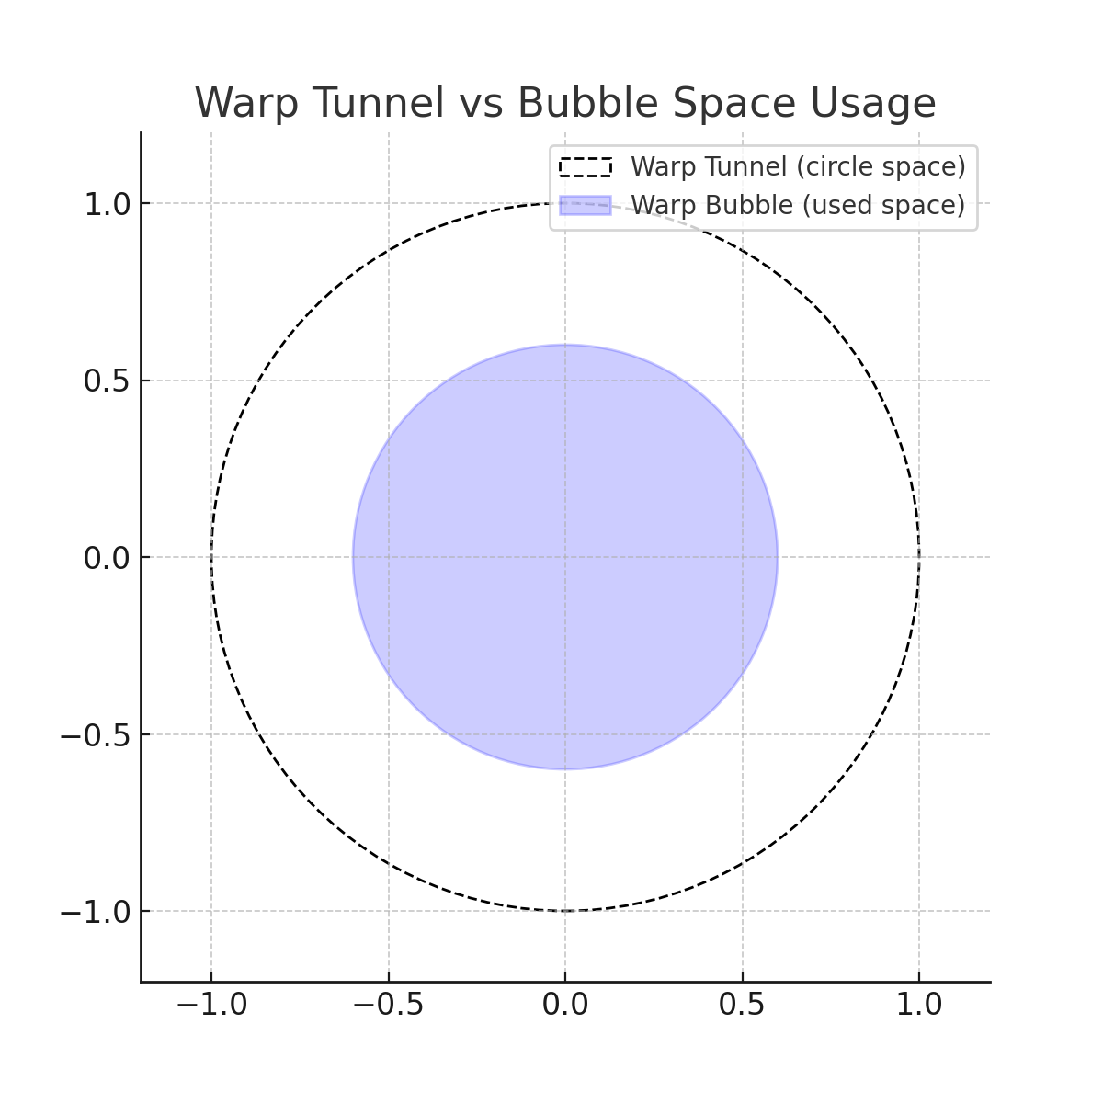

Diagram (Labeled)
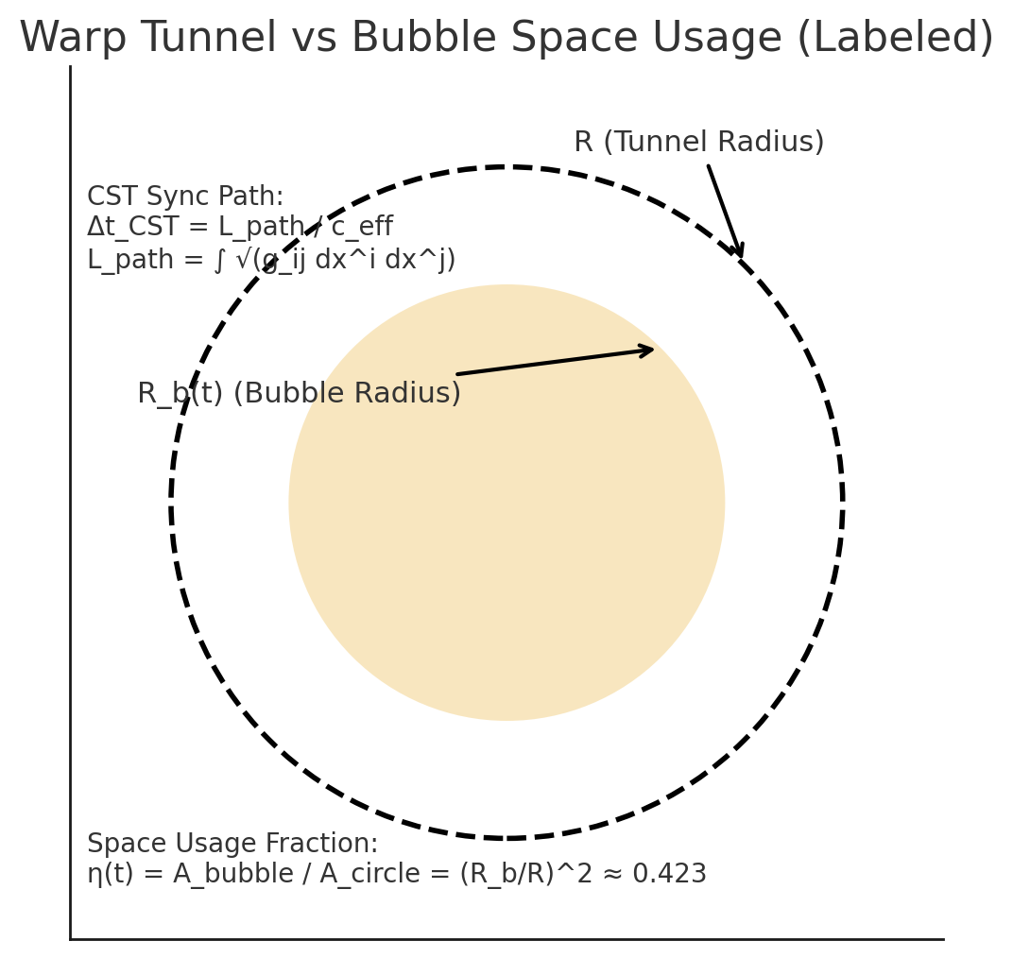
Figure 1. Warp Tunnel (outer circle, radius R) and Warp Bubble (inner disk, radius R_b). The shaded region is the ‘used space’ carried by the bubble. Stability requires η(t) = A_bubble/A_circle to remain ~constant, and CST sync uses Δt_CST = L_path/c_eff.

