Warp-Drive Energy Symmetry Engine
This document explains the conceptual foundation of the Warp-Drive Energy Symmetry Engine, based on energy–matter symmetry, vacuum field coupling, and CST time synchronization.

1. Energy–Matter Symmetry Loop
In classical and quantum physics, energy and mass are interchangeable according to Einstein’s equation, E = mc². This relationship forms the basis of pair creation and annihilation: high-energy photons can produce an electron–positron pair, and when they meet again, they annihilate to regenerate photons. This perfect reversibility creates an energy–matter symmetry loop.

2. The Vacuum as an Energy Reservoir
The quantum vacuum is not empty—it is filled with virtual particle pairs that constantly appear and disappear. If a warp drive can synchronize with these oscillations, it could momentarily access vacuum energy through quantum entanglement and Casimir-like cavities. These oscillations may serve as the medium through which energy transitions from virtual to real photons.

3. Warp Field Implication
By coupling photon regeneration with vacuum compression, photon pressure can emulate negative energy density. This effect could theoretically generate a spacetime curvature pattern—contracting space ahead and expanding it behind—similar to the Alcubierre warp bubble concept. In this configuration, the annihilation–creation cycle replaces exotic matter with a stabilized energy symmetry mechanism.

4. Engineering Analogy
The warp-drive symmetry engine functions like a quantum turbine:
1. Photons strike a vacuum field, producing matter–antimatter pairs.
2. The pairs exchange charge and momentum within an entanglement field.
3. They annihilate, releasing phase-aligned photons that drive curvature.
4. The cycle repeats at CST-synchronized frequency, maintaining thrust through energy symmetry.

5. Conceptual Summary
This system unites Einstein’s E=mc² with quantum symmetry, vacuum energy, and cosmic temporal alignment (CST). The Warp-Drive Energy Symmetry Engine demonstrates how annihilation–creation loops in the vacuum field could provide a sustainable mechanism for warp propulsion and spacetime manipulation.
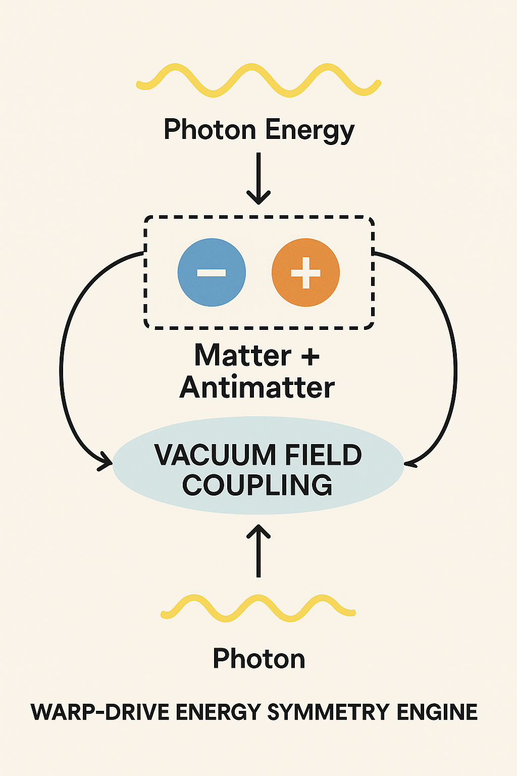
Figure 1: Warp-Drive Energy Symmetry Engine Diagram — illustrating photon creation, matter–antimatter loop, and vacuum field coupling.

