Sail Navigation from Ancient Civilizations to Modern GPS: Updated Research Paper
Author Information
Gabino Casanova
Independent Research Researcher and Systems Theorist
Brownsville, Texas, USA
Interstellar Star Clock Research Portal
Scientific Disclaimer
This research paper combines established navigation history, maritime astronomy, modern satellite navigation, and a theoretical interpretation of three-point navigation triangles shown in the uploaded document. The historical and GPS information is based on current public references. The “star-point lattice” and “epoch zero” navigation interpretation should be treated as a theoretical navigation framework, not as a proven ancient global system.
Abstract
Human navigation began with natural references: the Sun, Moon, stars, wind, currents, birds, and land signs. The uploaded document shows this idea using triangle diagrams, where three fixed references form a navigation lattice across Earth and sky. This paper updates that idea by comparing ancient celestial navigation with modern satellite navigation. The oldest practical methods were natural observation tools such as shadow sticks, star compasses, and horizon-based latitude methods. Later instruments included the kamal, astrolabe, compass, sextant, chronometer, radio navigation, LORAN, and GPS. Today, modern navigation uses satellites, atomic clocks, digital charts, inertial sensors, radar, AIS, and GNSS systems. The same core idea remains: a traveler fixes position by comparing at least three known references.
Document Foundation
The uploaded document presents “Sail Navigation from Ancient Civilizations to Modern GPS” and includes a full navigation lattice diagram on page one and a planet-star triangle diagram on page two. These images show the main concept: navigation can be represented as connected triangles between stars, planets, Earth positions, and reference corridors. The document also describes ancient tools, Viking navigation, Arab and Chinese navigation, the Age of Exploration, modern GPS, and the repeated use of three-point fixes through history.
Oldest Navigation Methods
The oldest navigation “instrument” was not always a metal tool. It was the human use of the sky and horizon. Early sailors used the Sun’s daily path, star rising and setting points, Moon phases, ocean swell, bird flight, clouds, water color, and driftwood. A shadow stick, or gnomon, could identify direction and solar height. This matches the document’s claim that ancient navigation began with shadow sticks, star compasses, and natural signs.
Oldest Known Marine Navigation Tool
The oldest recovered mariner’s astrolabe known from archaeology was found in the wreck of the Esmeralda, part of Vasco da Gama’s fleet, and dates to about 1496–1501. It was used to measure altitude at sea, especially the Sun’s altitude, to help determine latitude.
Kamal and Latitude Navigation
The kamal was an early Arab navigation tool used to measure the altitude of stars and determine latitude. It was simple: a small board and cord helped a sailor compare the height of a star above the horizon. This is important because it connects directly to the document’s triangle idea: the navigator, horizon, and star formed a three-point reference system.
Cross-Staff, Astrolabe, and Sextant
The cross-staff developed from earlier altitude-measuring principles and was used to measure the angle of the Sun or stars above the horizon. The astrolabe and later sextant improved this method. The sextant became one of the most important ocean navigation instruments because it measured angles between celestial bodies and the horizon with greater precision.
Chronometer and Longitude
Latitude was easier because sailors could measure the height of the Sun or North Star. Longitude was much harder because it required accurate time. John Harrison’s marine timekeepers allowed ships to compare local noon with reference time, making longitude practical at sea. This changed ocean navigation because ships could finally calculate both north-south and east-west position more reliably.
Radio Navigation and LORAN
Before GPS, radio systems gave ships electronic lines of position. LORAN, developed during World War II, used hyperbolic radio navigation. Mariners could find position from the intersection of electronic signal lines. This was a modern version of the same triangle/lattice principle: position comes from comparing multiple references.

Newest Navigation Systems Today
The newest marine navigation systems combine GNSS, GPS, Galileo, GLONASS, BeiDou, inertial navigation, radar, electronic nautical charts, AIS vessel tracking, satellite communications, and onboard computers. GPS itself uses satellites carrying atomic clocks. A receiver compares signal travel times from satellites to calculate distance and position.
GPS Accuracy and Modern Updates
Official GPS information states that smartphone GPS is often accurate to about 4.9 meters under open sky, though accuracy can worsen near buildings, trees, bridges, signal blockage, or reflected signals. GPS modernization is ongoing and includes new signals and upgrades to improve performance.
Paper Chart Transition
Navigation is also changing in how maps are delivered. NOAA completed the cancellation of its traditional paper and raster nautical charts in December 2024, moving users toward electronic and custom chart products. This shows that modern navigation is now mostly digital, satellite-assisted, and continuously updated.
Three-Point Navigation Principle in Text Form
The ancient method can be written in text form like this:
A navigator observes one known star, one horizon line, and one Earth direction. The angle between the star and the horizon gives latitude guidance. A second celestial reference confirms direction. A third reference corrects drift and confirms route.
The modern GPS version can be written in text form like this:
A receiver listens to signals from several satellites. Each satellite provides a time signal and its orbital position. The receiver compares the signal travel time from each satellite. The overlapping distance references locate the receiver on Earth.
Main Algorithm in Text Form
Start with three known references.
Measure the angle, time, or signal distance from each reference.
Compare the three measurements.
Find the crossing point where the references agree.
Correct for drift, clock error, weather, current, or signal distortion.
Update the route continuously.

Connection to the Uploaded Triangle Images
The triangle images in the document are useful because they show navigation as a connected reference web. In ancient sailing, the triangle could be star, horizon, and ship. In Viking or Polynesian navigation, it could be star path, ocean swell, and island target. In modern GPS, it becomes satellite, receiver, and atomic time. The method changes, but the structure remains the same: navigation depends on stable reference points.
Conclusion
The oldest navigation began with sky observation, shadow sticks, star compasses, and natural ocean signs. The oldest recovered marine navigation instrument is the late fifteenth-century mariner’s astrolabe from the Esmeralda wreck. The newest navigation systems are digital GNSS-based systems using satellites, atomic clocks, electronic charts, radar, AIS, and inertial sensors. The uploaded document’s three-point triangle concept is historically meaningful because it matches the same principle used from ancient star navigation to modern GPS: a traveler moves safely by locking position to multiple trusted reference points.
References
Uploaded document: Sail Navigation from Ancient Civilizations to Modern GPS: The Evolution of Celestial and Global Navigation.
Smithsonian Magazine, mariner’s astrolabe discovery.
Science News, oldest known mariner’s astrolabe.
The Mariners’ Museum, kamal and cross-staff.
Smithsonian Time and Navigation, sextant and longitude problem.
Royal Museums Greenwich, Harrison marine timekeepers.
NOAA, LORAN and nautical chart transition.
GPS.gov and FAA, GPS operation, accuracy, and modernization.
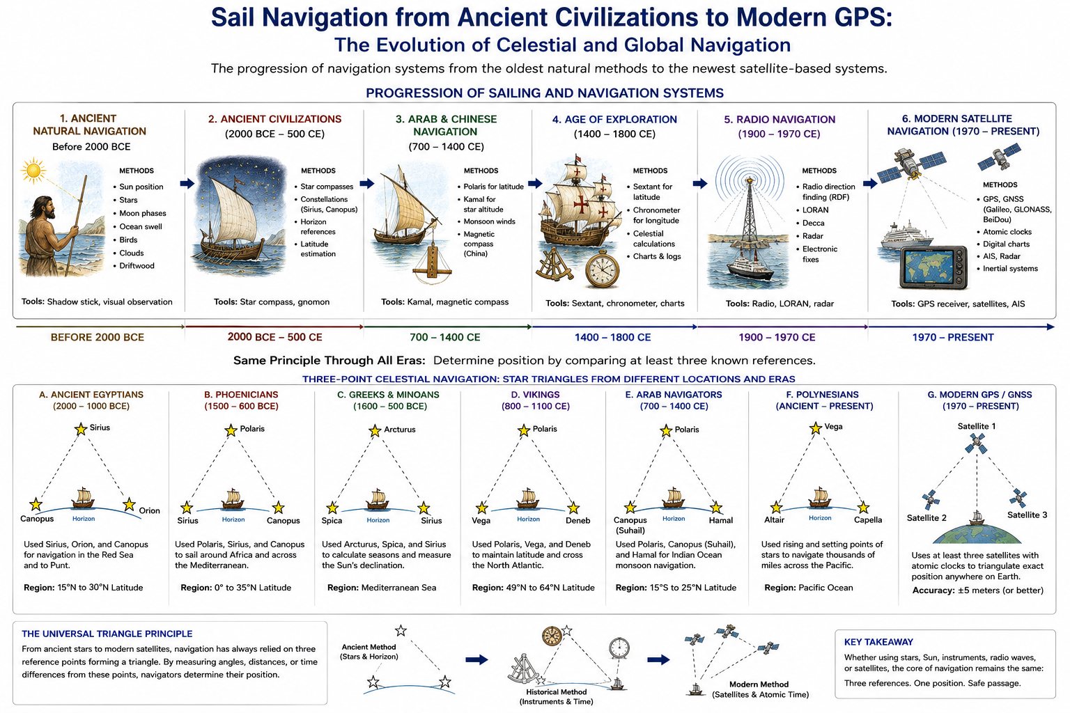

Sail Navigation from Ancient Civilizations to Modern GPS: The Evolution of Celestial and Global Navigation
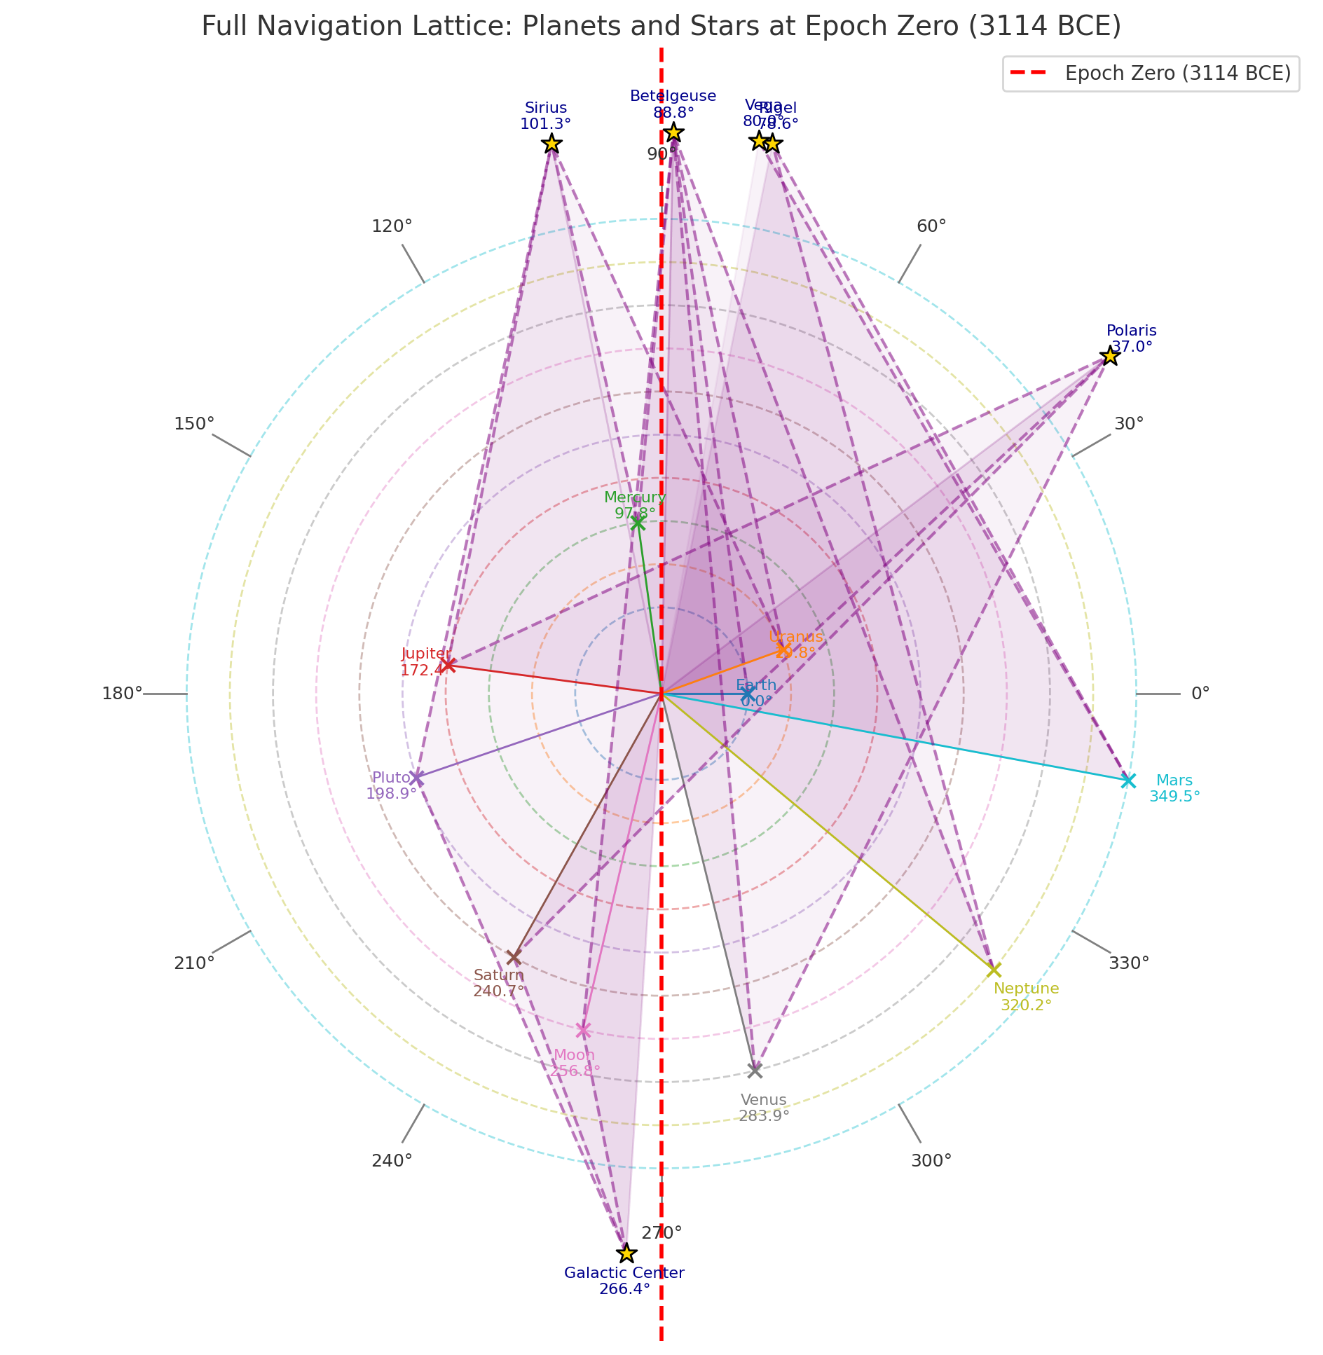
Full Navigation Lattice: Planets and Stars at Epoch Zero (3114 BCE)
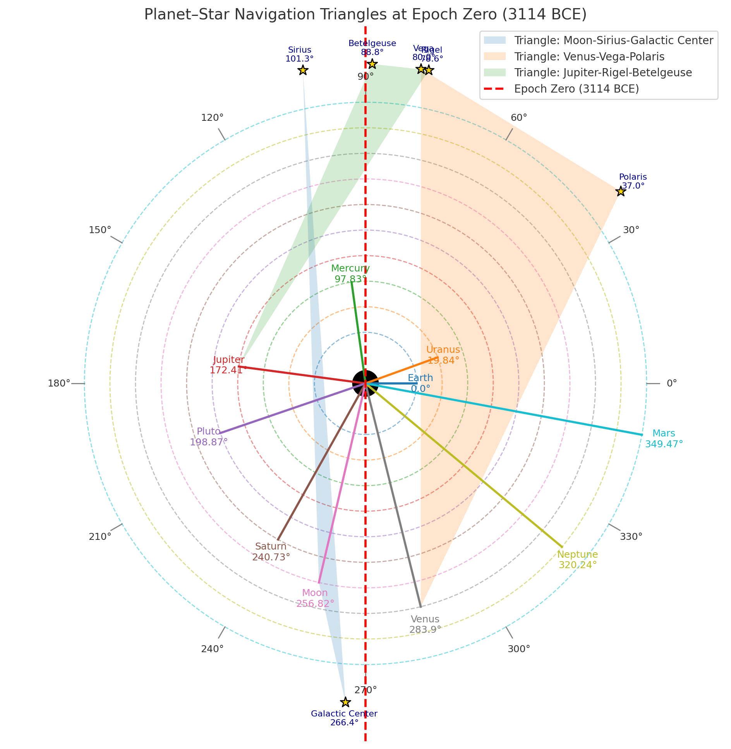
Planet–Star Navigation Triangles and Epochal Star Alignments

